Proceedings of IMEC 2019
International Mechanical Engineering Congress (IMEC-2019),
29th November- 1st December 2019, NIT Tiruchirappalli, India.
IMEC2019-xx-xxxx

Title

Author1^{a*}, Author2^{b},
ª Department of Mechanical Engineering, NIT Trichy
^{b} Department of Mechanical Engineering, NUS Singapore
* Corresponding author email: vedha@nitt.edu

ABSTRACT
Numerical simulations have been performed to study the growth of vapour film around the heated cylinders in stack and also the interaction among the neighbouring sites. A VOF solver coupled with energy equation and change of phase has been used for this purpose. Simulations have been carried out by maintaining the bulk domain at saturation temperature and cylinders at a superheat of 200 K. The interfacial interactions for two types of cylinder arrangements have been studied. Vertical in-line stack and rectangular array has been modelled and mutual interactions are reported. It has been observed that the bubble grows more freely over the cylinder which doesn’t have any neighbour showing preference in site. The motivation for the current work emanates from the conceptualization to improve the performance and emission characteristics of diesel engine fueled with biodiesel, by altering the fuel properties of it through the addition of additives. As such, 1,4-Dioxane, a multipurpose additive, has been zeroed in as one of the indispensible additive to be added with the optimum blend of KME (kapok methyl ester), a
biodiesel produced from under-utilized kapok oil, with diesel to improve the engine characteristics.
Keywords: Biodiesel 1,4-Dioxane, KME (kapok methyl ester),
Additive, Emission, Combustion

NOMENCLATURE
c_{p}= specific heat of mixture.
d = diameter of cylinder
i_{lv} = latent heat of phase change
k_{eff} = effective thermal conductivity
q_{pc}= heat flux
r_{c} = radius of centroid.
α = void fraction
µ= viscosity of fluid
ρ= density of fluid
INTRODUCTION
The increasing global demand for energy and rising level of greenhouse gas emissions have driven the need to find renewable source of alternate fuels for variety of practical combustion devices [1]. In such a scenario, biodiesel has emerged as a promising alternate fuel to replace a fraction of petroleum products, particularly for diesel engine applications [2]. Significantly, over the decades, there have been many contributions to the production and characterization of variety of biodiesel, produced from different species, for utilizing them in a diesel engine [3,4]. Son and Dhir [5] through numerical simulations found out that, with increase in wall superheat and contact angle there is an increase in the diameter of departing bubble. But, to avoid interaction related complexities, previous studies mainly focused on bubble release from single nucleation site. The interaction of neighbouring sites makes the phenomenon quite complex which leads to preference and suppression issues among bubble ejecting sites. Moreover, in engineering applications like evaporator coil, stack of interacting boiling surfaces are quite common. Hence, an effort needs to be developed to understand mutual interaction of neighbouring sites in stack. In present study, numerical simulations have been performed to study the bubble dynamics around a stack of wires.
GOVERNING EQUATIONS:
The governing equations solved for the simulation of boiling at nucleation sites include conservation equations for mass, momentum and energy. The mass conservation equation is given as,
$∇.u={\dot{v}}_{pc}$ (1)
Here, the term ${\dot{v}}_{pc}$ is the volume source per unit volume which is the source term used to indicate the dilatation rate which happens due to change of liquid phase to vapour during boiling. ${\dot{v}}_{pc}$ is calculated using the equation given below.
${\dot{v}}_{pc}=-\frac{{\dot{q}}_{pc}}{i_{LV}}\left(\frac{1}{ρ_{v}}-\frac{1}{ρ_{l}}\right)$ (2)
Where, ${\dot{q}}_{pc}$ is the heat flux associated with boiling and $i_{LV}$ is the enthalpy due to phase change.
The conservation equation for momentum is given as:
$\frac{∂(ρu)}{∂t}+∇.\left(ρuu\right)=-∇p^{'}+∇.τ+c_{hsp}ρg+f_{σ}$ (3)
where, $f_{σ}$ is the surface tension force near the interface.
To solve for the enthalpy, the thermal energy equation is used. The thermal energy equation is given by,
$\frac{∂(ρi)}{∂t}+∇.\left(ρui\right)=∇.\left(k_{eff}∇T\right)-{\dot{q}}_{pc }$ (4)
$α_{l}$ is the phase fraction field and is evaluated by using transport equation given in equation (5).
$\frac{∂(α_{l})}{∂t}+∇.\left(u^{*}α_{l}\right)=-{\dot{α}}_{l,pc }$ (5)
where, ${\dot{α}}_{l,pc}$ is the phase fraction source term and is calculated as:
${\dot{α}}_{l,pc}=-\frac{{\dot{q}}_{pc}}{ρi_{LV}}$ (6)
The fluid properties like density (ρ), viscosity (µ) are calculated by taking weighted averages of liquid and vapour phases.
$ρ=ρ_{l}α+ρ_{g}(1-α)$ (7)
$μ=μ_{l}α+μ_{g}(1-α)$ (8)
The specific heat of the fluid is calculated by:
$c_{p}=ρ^{-1}(α_{l}ρ_{l}c_{p,l}+\left(1-α_{l}\right)ρ_{v}c_{p,v})$ (9)
Engine layout and instrumentation

The equipment’s and other instrumentation involved in the experimentation are shown in Fig. 1. The engine being used for the current study is a typical single cylinder diesel engine, mainly used in agricultural or industrial applications. The constant speed naturally aspirated engine has been coupled with an eddy current dynamometer. The load applied to the engine is varied by changing the current supplied to the eddy current dynamometer and by this; an opposing electromagnetic force would be generated inside the rotor, which ably controls the applied load. solver, developed especially to model phase change heat transfer, called inter Thermal Phase Change Foam [3] has been used as numerical tool. Finite volume approach is used to discretize the governing equations. The pressure-velocity coupling is done by using PISO-semi implicit method.
Two types of wire arrangements have been considered in this study. Figure 1 shows the domain considered for simulation. To facilitate unrestricted bubble release from the vertical stack of wires, pressure outlet condition is given at top boundary. Bulk liquid domain along with the domain boundaries are kept at saturation temperature. Simulations are initiated with thin vapour layer of thickness 1/10th of the diameter of wires, around superheated cylindrical wires. The wires are maintained at a temperature of 200 K more than the saturation temperature of water.
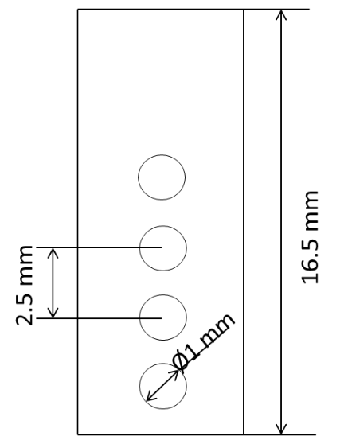
2
4
3
1
(a)
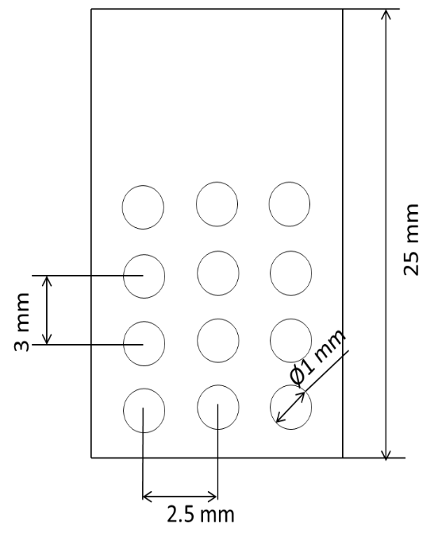
8
7
6
5
4
3
2
1
(b)
Figure 1: Types of wire arrangements considered for the numerical analysis

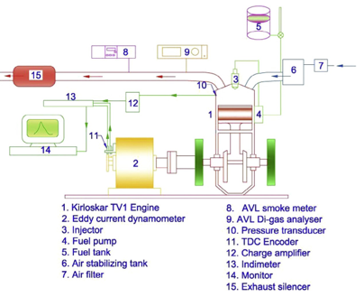
Figure 2. Schematic diagram of the experimental setup

RESULTS AND DISCUSSIONS
The growth of vapour film around the cylinders and the interfacial interactions among growing films around the cylinders placed in a vertical stack have been studied through simulations. Since the cylinders are maintained at a 200 K superheat, the liquid present in the domain undergo phase change. To show this phase change process and also the way in which the vapour film grows, phase contours have been plotted at different time as shown in figure 2. In figure 2 the cylinder boundary has been marked in red for easy visualization. It can be observed from the figure that till t = 0.01 s, identical films are formed around the cylinders. But as the time progresses, the vapour film around the cylinder 1 grows freely as compared to the films around rest cylinders.

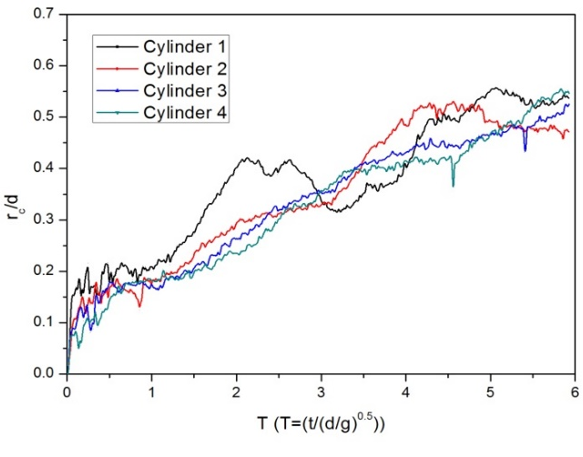
Figure 3. Temporal variation of centroid of vapour mass present around the cylinders.

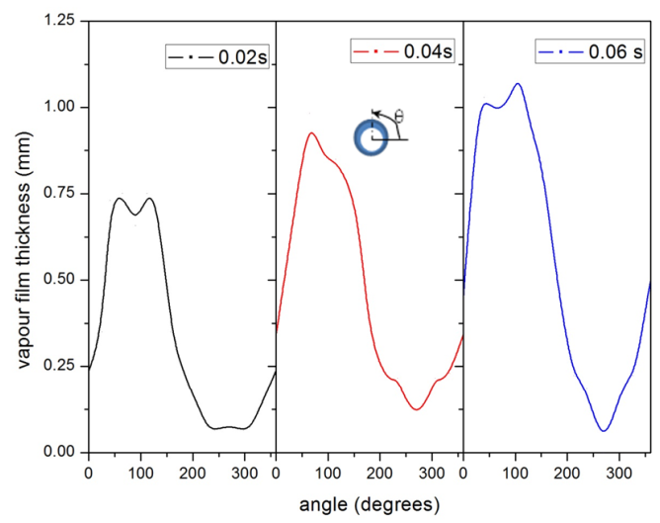
Figure 4: Angular variation of thickness of the film around cylinder 1 at different times.

The growth of vapour film around all the other cylinders is being suppressed. The suppression observed is due to the presence of neighbouring cylinders. Further, to have a clear idea about the growth of the vapour film, temporal variation of centroid of vapour mass around all the cylinders has been plotted and shown in figure 3. In the figure, it can be seen that the radius of centroid of cylinder 1 is more at the start, indicating faster growth of film. Radial profile of film thickness showed pseudo-periodicity, the amplitude of which is less for cylinders 2, 3 and 4 as compared to cylinder 1 due to suppression. It should be noted that despite all the variations in growth of the film, the film remains laterally symmetric around all the cylinders at all times. Figure 4 shows the angular variation of thickness of vapour film around cylinder 1 at different times. The angle is measured from the horizontal line which passes through the centre of the cylinder as shown in figure.

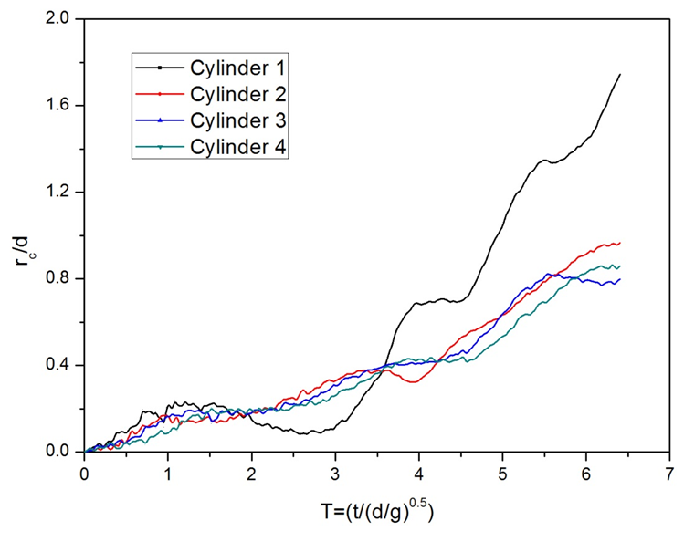 | 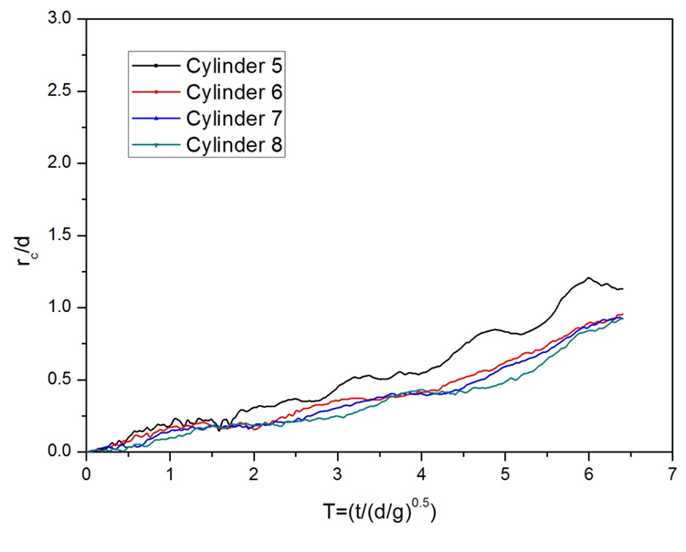
Figure 6. Temporal variation of centroid of vapour mass present around the cylinders in first column. | Figure 7. Temporal variation of centroid of vapour mass present around the cylinders in first column

It can be observed from the figure that the thickness of the film is more over the upper half of the cylinder as compared to the lower half at all times. This is due to the buoyancy effect, because of which we observe thickest vapour film on top of the cylinder and continuous azimuthal thinning. It can also be observed from figure 4 that the peak point of the graph is increasing with time, which shows that the thickness of the vapour film on top of the cylinder increases with time.
Vapour film growth around cylinders in stack of rectangular array
To observe the effect of cylinders in horizontal array as well as vertical direction on film growth, simulations have been carried out with arrangement of stack in rectangular array (Figure 1). Phase contours have been plotted at different time steps and shown in figure 5. To clearly visualize the difference in film growth around cylinders, zoomed view of two cylinders from the top row (red box) and two cylinders from the bottom row (green box) have been shown separately. It can be clearly seen from the figure that the vapour film present around the top cylinder grows freely, whereas, the vapour film around the lower cylinders gets suppressed due to the presence of cylinders above in vertical direction. The presence of neighbouring cylinders offers resistance to the growth of the vapour film around the lower cylinders.
Figure 6 and 7 shows the variation of centroid of vapour mass with time. The numbering of cylinders has been shown in figure 1. From figure 6, it is clear that the radius of centroid is more for the top cylinder (cylinder 1) as compared to other cylinders in the first column indicating that the film growth around the cylinder 1 is faster. Similarly, from figure 7, it can be observed that the vapour film growth is more for the first cylinder in the central column of cylinders (cylinder 5). By comparing the figures 6 and 7, one can note that the radius of centroid of vapour mass around cylinder 1 is more than that of cylinder 5. This indicates that among the cylinders in the top row, the vapour film grows more around the corner most cylinders (cylinder 1).
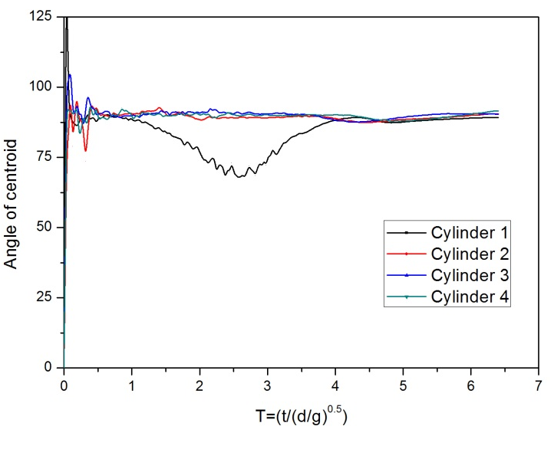
Figure 8. Angular variation of centroid with time

Further, from figure 5 it can be seen that along with vertical interactions, mutual lateral biasing of vapour growth is observed in stack of rectangular array. Lateral symmetry in the vapour growth depicts affinity of vapour film hinting towards bubble merging. Figure 8 shows the variation of centroid angle which is plotted to show the direction of movement of vapour film. A bell shaped nature of temporal traversal in location of vapour mass centroid supports possibility of bubble merging; even before release through nucleation.
There is a good amount of literature on performance investigation of closed loop GSHP systems. Menseh et al. [10] carried out a numerical analysis and an experimental investigation on the effect of building load and heat pump unit performance for vertical closed loop ground heat exchanger using Ground Loop Design (GLD) software and experimental investigation was conducted to validate the effects of peak load variation on the GLHX design. It was found that decrease in heat pump unit fluid flow rate led to decrease in the GLHX length in all operating modes and increment of COP of heat pump unit declined when operated in cooling mode. For an increase in 40% in cooling and heating load there was an increase of 44.45% and 69.24% in the GLHX length respectively. Zarrella et al. [11] made an investigation using a simulation model of GSHP system on how variable flow of heat carrier fluid of ground loop affects energy efficiency of the system. Single U-tube, double U-tube and coaxial pipe heat exchangers were analyzed. Three control strategies were investigated viz., constant mass flow rate of ground loop in both cooling and heating modes, constant temperature difference of 3°C and 5°C in heating and cooling mode respectively and the same temperature difference of 3°C for both the modes. For constant mass flow rate of ground loop the heat pump showed the best performance, 5°C temperature difference across heat pump in cooling mode led to 9 to 14% decrease of energy performance whereas 3°C temperature difference led to 4% degradation of energy performance. Li et al. [12] established a numerical model to investigate operation of horizontal spiral coil type GSHP system taking into account the geothermal gradient and changing ambient air temperature and compared circulating fluid temperature with or without considering the effect of COP of heat pump. Also they investigated the impacts of daily variation of thermal load and operation loads on system performance. It was found that temperature difference of fluid inlet temperatures could be 4.1% and 11.5% with and without considering the heat pump in heating and cooling models. Awani et al. [13] demonstrated a study on the performance of heat pump system assisted by geothermal and solar energy under the climate conditions of Tunisia. The system was designed and installed in Thermal Process Laboratory, Research and Technology Centre of Energy. Numerical model based on TRNSYS software was used on system with 14.8 m2 GHX surface area, 1 m depth of GHX, 0.3 m distance between two tubes and 8 m2 solar collector surface area. COP of the system reached 5.5 when the solar radiation intensity reached the maximum value at 13.00 h. They suggested that horizontal GHX can be used successfully for heating greenhouses since reduction in ground temperature did not exceed 1°C. Verma and Murugesan [14] made a study on the performance of Solar Assisted Ground Source Heat Pump system (SAGSHP) used for solar energy storage in day time and space heating in night time. Results showed that with increase in mass flow rate of circulating fluid the heat absorbed in solar collector increased from 2.07 to 2.56 kW and only 1.991 to 2.414 kW of solar heat was rejected into the ground during day time. About 21% increase in heat injection into the ground was achieved with increase of mass flow rate of heat transfer fluid in GHX and solar collector. Due to charging of the ground there was 23% increase of COP of the system.
Conclusions
Interfacial interactions are observed among growing films around the cylinders for two different types of cylinder arrangements, i.e. vertical in-line and rectangular array. Through simulations, following major finding came out:
- Suppression of film growth is noticed due to presence of neighbouring cylinders.
- Along with vertical interactions, mutual lateral biasing of vapour growth is observed in stack of rectangular array.
- Interfacial interaction is a major factor in deciding bubble release rate as well as heat transfer coefficients.
Findings from present simulations can be used for better design of rod bundles in evaporator stacks and nuclear reactors.
References
- Lee, Han Choon, Byung Do Oh, Sung Won Bae, and Moo Hwan Kim. 2003. “Single Bubble Growth in Saturated Pool Boiling on a Constant Wall Temperature Surface.” International Journal of Multiphase Flow 29 (12): 1857–74. doi:10.1016/j.ijmultiphaseflow.2003.09.003.
- Hetsroni, G., A. Mosyak, E. Pogrebnyak, I. Sher, and Z. Segal. 2006. “Bubble Growth in Saturated Pool Boiling in Water and Surfactant Solution.” International Journal of Multiphase Flow 32 (2): 159–82. doi:10.1016/j.ijmultiphaseflow.2005.10.002.
- Maurus, Reinhold, and Thomas Sattelmayer. 2006. “Bubble and Boundary Layer Behaviour in Subcooled Flow Boiling.” International Journal of Thermal Sciences 45 (3): 257–68. doi:10.1016/j.ijthermalsci.2004.05.006.
- Albadawi, A., D. B. Donoghue, A. J. Robinson, D. B. Murray, and Y. M C Delaur?? 2013. “On the Analysis of Bubble Growth and Detachment at Low Capillary and Bond Numbers Using Volume of Fluid and Level Set Methods.” Chemical Engineering Science 90: 77–91. doi:10.1016/j.ces.2012.12.004.
- Nabil, Mahdi, and Alexander S. Rattner. 2016. “interThermalPhaseChangeFoam—A Framework for Two-Phase Flow Simulations with Thermally Driven Phase Change.” SoftwareX 5. Elsevier B.V.: 216–26. doi:10.1016/j.softx.2016.10.002.
- Son, Gihun, and Vijay K. Dhir. 2008. “Numerical Simulation of Nucleate Boiling on a Horizontal Surface at High Heat Fluxes.” International Journal of Heat and Mass Transfer 51 (9-10): 2566–82. doi:10.1016/j.ijheatmasstransfer.2007.07.046.

